PART A
(Part A: TO BE REFFERED BY STUDENTS)
A.1 AIM:
To develop a mini project using Java that implements basic programming concepts and collections to create a functional application for managing kidswear inventory.
A.2 Pre requisite:
Basic knowledge of Java programming including concepts like classes, objects, methods, and control statements. Understanding of Java Collections (especially ArrayList) and basic file handling is also required.
A.3 Outcome:
After successful completion of this experiment, students will be able to develop a standalone Java application using basic programming concepts. They will understand the use of classes, objects, and collections like ArrayList. Students will also learn how to perform file handling using CSV files. The project improves logical thinking and problem-solving skills.
A.4 Theory:
A mini project in Java helps in applying programming concepts to build real-world applications. It uses basic concepts like classes, objects, and methods. The project also uses ArrayList for dynamic data storage. File handling is used to save and load data using a CSV file. This ensures that data is not lost after closing the program. Overall, it demonstrates how Java can be used to create simple and useful applications.
A.5 Procedure/Task:
- Identify the problem and select the project topic (Kidswear Inventory System).
- Design the structure of the program using classes and objects.
- Implement the application using Java programming concepts.
- Use ArrayList to store and manage kidswear item data.
- Implement functions like add, view, search, update, and delete items.
- Apply file handling to load and save data using a CSV file.
- Compile and run the program to test its functionality.
- Prepare the project documentation and save the file as required.
PART B
(PART B: TO BE COMPLETED BY STUDENTS)
(Students must submit the soft copy as per following segments within two hours of the practical. The soft copy must be uploaded on the Blackboard or emailed to the concerned lab in charge faculties at the end of the practical in case the there is no Black board access available)
Roll No. : | Name:
Class : | Batch :
Date of Experiment : | Date/Time of Submission :
Grade :

B.1 Project Details
(Detailed description of project. It should include answers to following questions)
1) Motivation to take the proposed project
The motivation behind this project is to create a simple inventory management system for a kidswear clothing section. Managing stock manually is difficult and error-prone. This project helps in organizing product details like brand, price, and quantity efficiently. It also improves understanding of Java concepts like classes, objects, and collections. It is useful for small shops to maintain records digitally.
2) Working of project
The project is a console-based Java application that manages kidswear items. It allows users to add, view, search, update, and delete items from inventory. The system uses ArrayList to store data dynamically. It also supports file handling by loading and saving data using a CSV file. When the program starts, it loads existing data, and when it exits, it saves updated data. This ensures data persistence.
3) Advantages & disadvantages of project
Advantages:
- Easy to use and understand
- Reduces manual errors
- Data is stored permanently using CSV
- Fast searching and updating of items
- Uses simple Java concepts
Disadvantages:
- No graphical user interface (GUI)
- Limited to basic features
- Not suitable for large-scale businesses
- No security or login system
4) Technologies used for developing the project
- Java Programming Language
- Java Collections (ArrayList)
- File Handling (BufferedReader, FileWriter, PrintWriter)
- CSV File for data storage
- Scanner class for user input
B.2 Output :
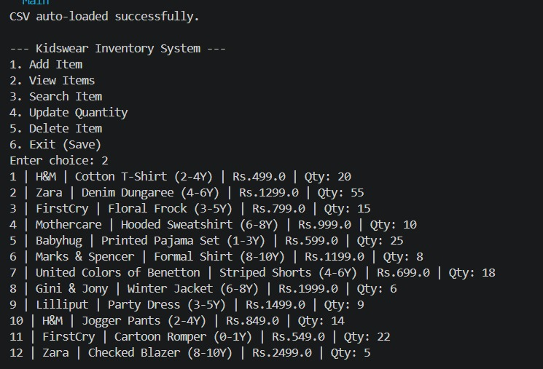
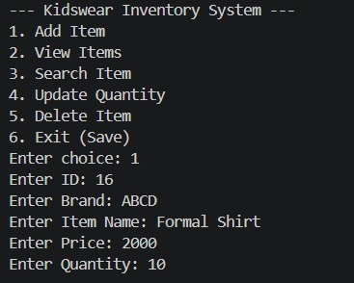
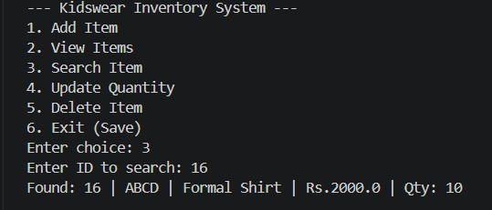
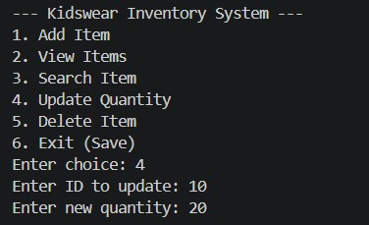
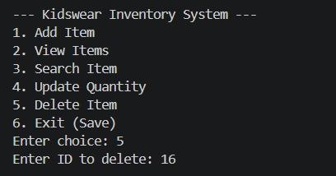
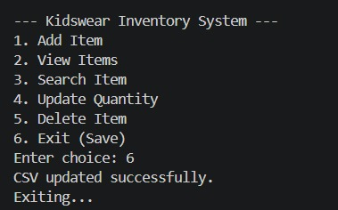
B.3 Project Code :
import java.util.*;
import java.io.*;

class Kidswear {
int id;
String brand;
String name;
double price;
int quantity;

Kidswear(int id, String brand, String name, double price, int quantity) {
this.id = id;
this.brand = brand;
this.name = name;
this.price = price;
this.quantity = quantity;
}

public String toString() {
return id + " | " + brand + " | " + name + " | Rs." + price + " | Qty: " + quantity;
}
}

class Inventory {
ArrayList<Kidswear> kidswear = new ArrayList<>();

void addItem(Kidswear k) {
kidswear.add(k);
}

void viewItems() {
if (kidswear.isEmpty()) {
System.out.println("No items in inventory.");
return;
}
for (Kidswear k : kidswear) {
System.out.println(k);
}
}

void searchItem(int id) {
for (Kidswear k : kidswear) {
if (k.id == id) {
System.out.println("Found: " + k);
return;
}
}
System.out.println("Item not found.");
}

void updateItem(int id, int qty) {
for (Kidswear k : kidswear) {
if (k.id == id) {
k.quantity = qty;
return;
}
}
System.out.println("Item not found.");
}

void deleteItem(int id) {
kidswear.removeIf(k -> k.id == id);
}

// Load CSV
void loadFromCSV(String filePath) {
try (BufferedReader br = new BufferedReader(new FileReader(filePath))) {
String line;
br.readLine(); // skip header

while ((line = br.readLine()) != null) {
String[] data = line.split(",");

int id = Integer.parseInt(data[0].trim());
String brand = data[1].trim();
String name = data[2].trim();
double price = Double.parseDouble(data[3].trim());
int qty = Integer.parseInt(data[4].trim());

kidswear.add(new Kidswear(id, brand, name, price, qty));
}

System.out.println("CSV auto-loaded successfully.");
} catch (Exception e) {
System.out.println("No CSV found or error reading file.");
}
}

// Save CSV
void saveToCSV(String filePath) {
try (PrintWriter pw = new PrintWriter(new FileWriter(filePath))) {
pw.println("id,brand,name,price,quantity");

for (Kidswear k : kidswear) {
pw.println(k.id + "," + k.brand + "," + k.name + "," + k.price + "," + k.quantity);
}

System.out.println("CSV updated successfully.");
} catch (Exception e) {
System.out.println("Error writing CSV.");
}
}
}

public class Main {
public static void main(String[] args) {
Scanner sc = new Scanner(System.in);
Inventory inv = new Inventory();

String file = "kidswear.csv";
inv.loadFromCSV(file);

while (true) {
System.out.println("\n--- Kidswear Inventory System ---");
System.out.println("1. Add Item");
System.out.println("2. View Items");
System.out.println("3. Search Item");
System.out.println("4. Update Quantity");
System.out.println("5. Delete Item");
System.out.println("6. Exit (Save)");
System.out.print("Enter choice: ");

int ch = sc.nextInt();

switch (ch) {
case 1:
System.out.print("Enter ID: ");
int id = sc.nextInt();
sc.nextLine();

System.out.print("Enter Brand: ");
String brand = sc.nextLine();

System.out.print("Enter Item Name: ");
String name = sc.nextLine();

System.out.print("Enter Price: ");
double price = sc.nextDouble();

System.out.print("Enter Quantity: ");
int qty = sc.nextInt();

inv.addItem(new Kidswear(id, brand, name, price, qty));
break;

case 2:
inv.viewItems();
break;

case 3:
System.out.print("Enter ID to search: ");
inv.searchItem(sc.nextInt());
break;

case 4:
System.out.print("Enter ID to update: ");
int uid = sc.nextInt();

System.out.print("Enter new quantity: ");
int newQty = sc.nextInt();

inv.updateItem(uid, newQty);
break;

case 5:
System.out.print("Enter ID to delete: ");
inv.deleteItem(sc.nextInt());
break;

case 6:
inv.saveToCSV(file);
System.out.println("Exiting...");
return;

default:
System.out.println("Invalid choice.");
}
}
}
}
B.4 Conclusion:
This project successfully demonstrates the development of a standalone Java application using basic programming concepts and collections. It helps in managing kidswear inventory efficiently with operations like add, search, update, and delete. The use of file handling ensures data persistence. Overall, the project meets the objective of building a simple and functional inventory system.
B.5 Observations and Learning:
During this project, I learned how to use Java classes and objects effectively. I understood the use of ArrayList for dynamic data storage. I also gained knowledge about file handling using CSV files. The project improved my logical thinking and problem-solving skills. It also helped me understand how real-world applications are developed using Java.

